1. ABSTRACT
This report presents a logical design and tested Flowgorithm demonstration for a Farmers Trading Market Information System in Sierra Leone. The design allows registered farmers or their authorised assistants to create produce listings, enables buyers to find active offers, and supports authorised quantity/price changes and SOLD status updates. Computational thinking, algorithms, modular functions, Boolean decisions and iteration are used to model a community information challenge. A working in-memory demonstration uses fixed-size shared arrays, sample registration records and farmer–assistant relationships; it does not provide persistent data storage, a live market platform or market-price verification. The proposed approach supports SDG 2 through potential improvements in access to market information, with further possible contributions to SDG 8.

2. INTRODUCTION
Agricultural trading depends on buyers and sellers having timely information about what is available, in what quantity, at what asking price and in which location. In Sierra Leone, a smallholder farmer may communicate availability through personal contacts or market intermediaries, while a buyer may need to make several enquiries before identifying suitable produce. These are plausible local information challenges that should be checked with farmers and traders before deployment; they are not presented here as findings from a completed survey. The proposed Farmers Trading Market Information System addresses the narrower, manageable problem of organising produce listings and making them searchable. The assignment demonstrates the programming logic needed to design such a service, rather than requiring a finished website or application.

3. REPORT RATIONALE AND PROBLEM ANALYSIS
3.1 Problem description and background
The specific problem is limited access to reliable, timely and organised information about produce offered for sale. A farmer may have harvested cassava, rice or vegetables but lack a consistent channel for informing potential buyers about quantities and asking prices. Buyers may rely on incomplete or outdated messages. Even where information exists, inconsistent units (for example, bag versus kilogram) can cause misunderstandings. The design cannot independently solve transport costs, crop spoilage, low purchasing power or market-price volatility; its intended contribution is improved information discovery and listing maintenance.

3.2 Who is affected and why it matters
Small-scale farmers may miss potential enquiries; buyers and local traders may spend time searching; and market assistants may need to reconcile changing information manually. An organised listing record can make the available information easier to compare and update, while leaving buyers and sellers responsible for confirming quality, availability, price and arrangements before any transaction.

3.3 Proposed solution and scope
The proposed system organises farmer-provided produce information in ACTIVE and SOLD listings. The Flowgorithm demonstration stores up to 50 listings in parallel arrays, verifies a farmer against a sample registered-farmers collection, and checks owner or delegated-assistant authority through sample farmer–assistant relationship records. Buyers search for an exact product name and optionally a location; only ACTIVE listings are displayed. The owner or an authorised assistant can update positive quantity and price values or mark a listing SOLD. This is an academic prototype: data does not survive termination, and no payment, delivery, database or real-time market-price service is supplied.

3.4 Aim and objectives
Aim: To design a simple, accessible and logically consistent produce-information service linking farmers and potential buyers in Sierra Leone.
- Record farmer identities or authorised assistant relationships with minimum necessary information.
- Create listings with product, quantity, unit, asking price, location and approved contact method.
- Reject incomplete, non-numeric or non-positive quantity and price values.
- Search ACTIVE listings by product and optional location.
- Allow authorised changes to listing quantity, price and status.
- Demonstrate all major outcomes through algorithms, pseudocode, flowcharts and sample scenarios.

3.5 Computational thinking
Technique | Application to this project
Decomposition | Separate farmer identification, listing creation, validation, search, update and status management.
Pattern recognition | All listings use the same core fields and validation checks regardless of crop type.
Abstraction | Store only information needed for discovery; exclude payments, logistics and complex agricultural records.
Algorithm design | Define ordered, finite steps with explicit conditions, loops and outcomes for each operation.

3.6 SDG alignment and community impact
The clearest alignment is SDG 2 (Zero Hunger), particularly the objective of supporting small-scale food producers through better access to markets and information. SDG 8 (Decent Work and Economic Growth) is a secondary connection through potential support for small traders. These are potential contributions rather than measured outcomes. The project may reduce repeated enquiries and improve visibility of available produce if farmers maintain accurate records. A pilot should evaluate whether listings remain current and whether users can access them affordably (United Nations, n.d.; FAO, n.d.).

3.7 Open source, Digital Public Goods and sustainability
Publishing the future implementation under an appropriate open-source licence could allow local developers, universities and community groups to inspect and adapt the software. The design files may also be shared with clear reuse terms. Open source does not automatically qualify a project as a Digital Public Good: a future implementation would need to meet applicable Digital Public Goods Standard requirements, including licensing, privacy, security and SDG relevance (Digital Public Goods Alliance, n.d.). Sustainability would require an organisation to maintain records, support market assistants and respond to inaccurate listings. Access through an assistant is included in the initial scope; USSD and SMS are future possibilities, not claimed implemented functions.

4. SYSTEM REQUIREMENTS AND LOGICAL DESIGN

4.1 Actors and access rules
Actor | Permitted activities
Farmer | Create, view, update and mark own produce listings SOLD.
Buyer | Search and view ACTIVE listings; use seller-approved contact method.
Market assistant | Create and maintain listings only for farmers who authorised the assistant.
Assumption for the logical model: an existing farmerID identifies a farmer; the authorised actor is established before changes are allowed. Registration and assistant authorisation are administrative prerequisites rather than an invented digital identity-verification service. A buyer need not register to search.

4.2 Input–process–output
Operation | Inputs | Processing | Output
Add | farmerID, product, quantity, unit, price, location, contact preference | Check authorisation and required values; generate ID; save ACTIVE | Confirmation and listingID or error
Search | product, optional location | Loop through listings; filter ACTIVE and matching records | Matching list or no-results message
Update | actorID, listingID, new quantity and price | Check ownership/delegation and values; save changes | Update confirmation or rejection
Mark sold | actorID, listingID | Check authorisation and ACTIVE status; set SOLD | Status confirmation or rejection

4.3 Record structure, variables and constants
Identifier | Type | Meaning / rule
farmerID, actorID, listingID | String | Identifiers; listingID must be unique.
productName, unit, location | String | Required non-empty listing information.
quantity, pricePerUnit | Decimal | Numeric and strictly greater than 0.
contactPreference | String | Seller-approved contact method; consent required for display.
status | String | ACTIVE or SOLD in this first version.
updatedDate | DateTime (design only) | Proposed last-modified field; NOT stored by the current Flowgorithm prototype.
results | List of Listing | Matching ACTIVE listings.
MIN_POSITIVE | Constant = 0 | A valid numeric quantity or price must exceed this threshold.
isAuthorised | Boolean | TRUE only for owner or delegated assistant.

4.4 Validation and Boolean rules
The demonstrated entry rule requires non-empty product name, unit, location and contact preference, plus quantity > 0 and price > 0 (quantities and prices are Real inputs in Flowgorithm). RETRY/CANCEL controls invalid-entry handling. Search uses exact, case-sensitive text equality for product and optional location while filtering status = ACTIVE. Updates and SOLD changes require the requested listing to exist, to be ACTIVE, and the actor to be its owner or a specifically authorised assistant. This prototype does not perform trim/case-fold matching, timestamp updates or validation of free-text content beyond non-empty values.

4.5 Boundaries and limitations
The executable Flowgorithm prototype maintains records only in memory using parallel arrays with a 50-listing capacity. It seeds F001 as a demonstration registered farmer and A002 as that farmer’s sample authorised assistant; these are not live registration or identity services. Listings are not preserved after program termination, no updatedDate field is stored, and searches are case-sensitive rather than trimmed/case-insensitive. Contact preference is displayed as entered, without a real consent-management service. No database, online authentication, payments, delivery, verified prices or field evaluation is claimed. These limits are consistent with the assignment’s requirement to design logical solutions rather than deploy production software.

h5. ALGORITHM DESIGN
The five step-by-step algorithms below follow the tested Flowgorithm structure. Shared data are passed as parameters; only the demonstration registration and authorization records are initialized in Main. The design deliberately excludes a live database or delivery/payment functionality.

Algorithm A — Add a produce listing
1. Receive farmer ID and actor ID. Check registered farmer identity using FarmerExists; otherwise show registration-required message.
2. Use ISAuthorised to check whether the actor is the farmer or a linked assistant; deny access if not.
3. Enter product name, quantity, unit, price per unit, location and approved contact preference.
4. If a required text value is empty or quantity/price is not positive, display a validation message and ask RETRY or CANCEL. RETRY repeats all produce inputs; CANCEL ends without storing.
5. If inputs are valid but 50 records already exist, show storage-full message and end.
6. Otherwise create ID L + (listingCount + 1), set status ACTIVE, save all fields in the corresponding array positions and increase listingCount by one.
7. Display the created listing and return to Main.

Algorithm B — Search active listings
1. Request product name and an optional location; reject blank product name.
2. Set found = FALSE and scan records from index 0 to listingCount − 1.
3. A record matches only if it is ACTIVE, product text exactly equals the search text and the location is blank or exactly matches the stored location.
4. Display the matching listing ID, product, quantity, unit, price, location, contact preference and status; mark found = TRUE.
5. If none match, display the no-results message; return to Main.

Algorithm C — Update a listing
1. Request actor ID and listing ID; scan listingIDs to find the target position.
2. If missing, display not-found; otherwise read its owner and current status.
3. Reject actors who fail ISAuthorised for that owner; reject SOLD listings.
4. Request new quantity and price, requiring both to be positive.
5. Write the approved values to quantities and prices at the found position, then display confirmation. No timestamp is stored.

Algorithm D — Mark a listing SOLD
1. Request actor ID and listing ID; find the record in listingIDs.
2. Reject missing records and actors not authorised for the listing owner.
3. If status is not ACTIVE, display the already-inactive message.
4. Otherwise set statuses[foundIndex] to SOLD and display a confirmation. ACTIVE searches then exclude this listing.

Algorithm E — Identify a farmer
1. Request actor ID and farmer ID.
2. Call FarmerExists against the separate registeredFarmerIDs collection; if absent, display registration required and return FALSE.
3. Otherwise call ISAuthorised for the farmer–actor pair.
4. Return TRUE with an authorised message when the actor owns the ID or has a matching farmer–assistant relationship; otherwise return FALSE with an access-denied message.

6. PSEUDOCODE
This section documents the implemented Flowgorithm demonstration using language-independent notation. Function names, array fields, capacity and program outcomes match the reviewed .fprg file. Array parameters represent references to shared in-memory records. FOR loops scan indices 0 through count − 1. Text matching is exact and case-sensitive. The initial sample data are illustrative, not a permanent farmer register.

6.1 Main and shared data
PROCEDURE Main
DECLARE listingIDs[50], farmerIDs[50], products[50], units[50] AS String
DECLARE locations[50], contacts[50], statuses[50] AS String
DECLARE quantities[50], prices[50] AS Real
DECLARE registeredFarmerIDs[50], authorizedFarmerIDs[50] AS String
DECLARE authorizedAssistantIDs[50] AS String
DECLARE listingCount, farmerCount, relationshipCount, option AS Integer
DECLARE identificationResult AS Boolean
listingCount <- 0
registeredFarmerIDs[0] <- "F001"; farmerCount <- 1
authorizedFarmerIDs[0] <- "F001"
authorizedAssistantIDs[0] <- "A002"; relationshipCount <- 1
option <- -1
WHILE option != 0
DISPLAY menu options 1 Add, 2 Search, 3 Update, 4 Sold, 5 Identify, 0 Exit
INPUT option
IF option == 0 THEN DISPLAY "Goodbye"
ELSE IF option < 1 OR option > 5 THEN DISPLAY "Invalid option"
ELSE IF option == 1 THEN
listingCount <- AddListing(sharedListingArrays, listingCount,
registeredFarmerIDs, farmerCount,
authorizedFarmerIDs, authorizedAssistantIDs, relationshipCount)
ELSE IF option == 2 THEN
CALL SearchListings(sharedListingArrays, listingCount)
ELSE IF option == 3 THEN
CALL UpdateListing(sharedListingArrays, listingCount,
authorizedFarmerIDs, authorizedAssistantIDs, relationshipCount)
ELSE IF option == 4 THEN
CALL MarkListingSold(listingIDs, farmerIDs, statuses, listingCount,
authorizedFarmerIDs, authorizedAssistantIDs, relationshipCount)
ELSE
identificationResult <- IdentifyFarmer(registeredFarmerIDs, farmerCount,
authorizedFarmerIDs, authorizedAssistantIDs, relationshipCount)
END IF
END WHILE
6.2 Registered-farmer lookup
FUNCTION FarmerExists(farmerID, registeredFarmerIDs, farmerCount) RETURNS Boolean
exists <- FALSE
IF farmerCount > 0 THEN
FOR i <- 0 TO farmerCount - 1
IF registeredFarmerIDs[i] == farmerID THEN exists <- TRUE END IF
END FOR
END IF
RETURN exists
END FUNCTION

6.3 Owner and delegated-assistant authorization
FUNCTION ISAuthorised(actorID, farmerID, authorizedFarmerIDs,
authorizedAssistantIDs, relationshipCount) RETURNS Boolean
authorized <- FALSE
IF actorID == farmerID THEN
authorized <- TRUE
ELSE IF relationshipCount > 0 THEN
FOR i <- 0 TO relationshipCount - 1
IF authorizedFarmerIDs[i] == farmerID AND
authorizedAssistantIDs[i] == actorID THEN
authorized <- TRUE
END IF
END FOR
END IF
RETURN authorized
END FUNCTION

6.4 AddListing
FUNCTION AddListing(sharedListingArrays, listingCount,
registeredFarmerIDs, farmerCount,
authorizedFarmerIDs, authorizedAssistantIDs,
relationshipCount) RETURNS Integer
updatedCount <- listingCount
INPUT farmerID, actorID
IF NOT FarmerExists(farmerID, registeredFarmerIDs, farmerCount) THEN
DISPLAY "Farmer not found. Registration required"
RETURN updatedCount
END IF
IF NOT ISAuthorised(actorID, farmerID, authorizedFarmerIDs,
authorizedAssistantIDs, relationshipCount) THEN
DISPLAY "Access denied"
RETURN updatedCount
END IF
listingComplete <- FALSE
WHILE listingComplete == FALSE
INPUT productName, quantity, unit, pricePerUnit, location, contactPreference
valid <- productName != "" AND unit != "" AND location != "" AND
contactPreference != "" AND quantity > 0 AND pricePerUnit > 0
IF valid THEN
IF listingCount < 50 THEN
listingID <- "L" + ToString(listingCount + 1)
status <- "ACTIVE"
listingIDs[listingCount] <- listingID
farmerIDs[listingCount] <- farmerID
products[listingCount] <- productName
quantities[listingCount] <- quantity
units[listingCount] <- unit
prices[listingCount] <- pricePerUnit
locations[listingCount] <- location
contacts[listingCount] <- contactPreference
statuses[listingCount] <- status
updatedCount <- listingCount + 1
DISPLAY "Produce listing created successfully", listingID
ELSE
DISPLAY "Storage is full"
END IF
listingComplete <- TRUE
ELSE
DISPLAY "Invalid listing. RETRY or CANCEL?"
INPUT choice
IF choice == "CANCEL" THEN
DISPLAY "Listing cancelled"
listingComplete <- TRUE
END IF
END IF
END WHILE
RETURN updatedCount
END FUNCTION

6.5 SearchListings
PROCEDURE SearchListings(sharedListingArrays, listingCount)
INPUT searchProduct, searchLocation
IF searchProduct == "" THEN DISPLAY "Enter a product name"; RETURN END IF
found <- FALSE
IF listingCount > 0 THEN
FOR i <- 0 TO listingCount - 1
IF statuses[i] == "ACTIVE" AND products[i] == searchProduct AND
(searchLocation == "" OR locations[i] == searchLocation) THEN
DISPLAY listingIDs[i], products[i], quantities[i], units[i],
prices[i], locations[i], contacts[i], statuses[i]
found <- TRUE
END IF
END FOR
END IF
IF found == FALSE THEN DISPLAY "No matching active listings found" END IF
END PROCEDURE

6.6 UpdateListing
PROCEDURE UpdateListing(listingIDs, farmerIDs, quantities, prices,
statuses, listingCount, authorizedFarmerIDs,
authorizedAssistantIDs, relationshipCount)
INPUT actorID, listingID
foundIndex <- -1
IF listingCount > 0 THEN
FOR i <- 0 TO listingCount - 1
IF listingIDs[i] == listingID THEN foundIndex <- i END IF
END FOR
END IF
IF foundIndex == -1 THEN DISPLAY "Listing not found"; RETURN END IF
farmerID <- farmerIDs[foundIndex]
IF NOT ISAuthorised(actorID, farmerID, authorizedFarmerIDs,
authorizedAssistantIDs, relationshipCount) THEN
DISPLAY "Access denied"; RETURN
END IF
IF statuses[foundIndex] != "ACTIVE" THEN
DISPLAY "Only ACTIVE listings can be updated"; RETURN
END IF
INPUT newQuantity, newPrice
IF newQuantity <= 0 OR newPrice <= 0 THEN
DISPLAY "Quantity and price must be greater than zero"; RETURN
END IF
quantities[foundIndex] <- newQuantity
prices[foundIndex] <- newPrice
DISPLAY "Listing updated successfully", listingID, newQuantity, newPrice
END PROCEDURE

6.7 MarkListingSold
PROCEDURE MarkListingSold(listingIDs, farmerIDs, statuses, listingCount,
authorizedFarmerIDs, authorizedAssistantIDs,
relationshipCount)
INPUT actorID, listingID
foundIndex <- -1
IF listingCount > 0 THEN
FOR i <- 0 TO listingCount - 1
IF listingIDs[i] == listingID THEN foundIndex <- i END IF
END FOR
END IF
IF foundIndex == -1 THEN DISPLAY "Listing not found"; RETURN END IF
farmerID <- farmerIDs[foundIndex]
IF NOT ISAuthorised(actorID, farmerID, authorizedFarmerIDs,
authorizedAssistantIDs, relationshipCount) THEN
DISPLAY "Access denied"; RETURN
END IF
IF statuses[foundIndex] != "ACTIVE" THEN
DISPLAY "Listing is not ACTIVE"; RETURN
END IF
statuses[foundIndex] <- "SOLD"
DISPLAY "Listing marked SOLD successfully", listingID
END PROCEDURE

6.8 IdentifyFarmer
FUNCTION IdentifyFarmer(registeredFarmerIDs, farmerCount,
authorizedFarmerIDs, authorizedAssistantIDs,
relationshipCount) RETURNS Boolean
isVerified <- FALSE
INPUT actorID, farmerID
IF NOT FarmerExists(farmerID, registeredFarmerIDs, farmerCount) THEN
DISPLAY "Farmer registration required"
ELSE IF ISAuthorised(actorID, farmerID, authorizedFarmerIDs,
authorizedAssistantIDs, relationshipCount) THEN
isVerified <- TRUE
DISPLAY "Farmer identified and actor authorized"
ELSE
DISPLAY "Farmer exists, but access is not authorized"
END IF
RETURN isVerified
END FUNCTION

7. FUNCTIONAL MODULES AND LOGICAL STRUCTURES
The tested Flowgorithm project contains eight functions. Main controls the user menu, while the other functions each implement a distinct operation. All shared listing and authorization collections are passed as function parameters. Their data are available only during the current run.
Function | Purpose / principal structures
Main | Menu repetition (WHILE), range and option selection (IF); initial arrays and sample registration.
AddListing | Farmer existence and delegated authority; WHILE retry/cancel; validate inputs; append parallel-array record.
SearchListings | FOR search across ACTIVE listings; product and optional-location decisions; display found/no-results.
UpdateListing | FOR search for ID; missing/authority/ACTIVE/positive-value IF checks; update indexed arrays.
MarkListingSold | FOR locate ID; authorization and status IF checks; set indexed status SOLD.
IdentifyFarmer | Call FarmerExists and ISAuthorised; return Boolean verification result.
farmerExists | FOR loop through separate registered-farmer IDs and Boolean comparison.
ISAuthorised | Owner equality or matching farmer–assistant pair, using IF and FOR.
IPO and data types: Inputs are entered via Flowgorithm Input symbols; processing is expressed through assignments, IF decisions, WHILE and FOR loops, and function calls; Outputs report matches, confirmations and errors. Boolean results control access, String arrays hold identifiers and text, Real arrays hold quantity and prices, and Integer counters bound loops.
Scope and limits: the seeded entries F001 and A002 are sample administrative records, not secure login or proof of real identity. Data are temporary, IDs are sequential within a single run, no persistent timestamp is captured, and case-sensitive text equality may fail for differently capitalized product/location names.

8. EXPECTED OUTPUTS AND LOGIC VERIFICATION
The scenarios below describe Flowgorithm console behavior observed during the user’s testing of the reviewed project and additional cases suitable for evidence screenshots. The sample prices are illustrative asking prices, not a survey or official market quotations. Attach genuine console images in Appendix B; an unfilled placeholder is not test evidence.
Scenario | Inputs / action | Expected console result
Menu | Launch program | Options 1–5 and 0 Exit appear.
Create listing | F001 or authorized assistant A002 adds Rice, 10 Bags, NLe 250, Bo | Creates L1 as ACTIVE and displays listing ID.
Search active | Search Rice / Bo | Shows listing L1 and approved contact preference.
Update | Owner F001 updates L1 to 20 Bags, NLe 300 | Displays update confirmation; subsequent search shows updated data.
Sold | Mark L1 SOLD, then search Rice / Bo | Confirms SOLD; active search does not return L1.
Invalid input | Quantity 0, choose RETRY; then valid quantity | Asks again and creates only a valid listing.
Cancel | Invalid entry, choose CANCEL | Displays cancellation and saves no listing.
Unauthorized actor | Actor X999 attempts change to F001 listing | Access denied; stored listing unchanged.
Farmer not registered | Identify F999 | Displays farmer registration required and returns FALSE.
Valid assistant | Identify actor A002 for F001 | Returns TRUE for the sample farmer–assistant relationship.

9. GITHUB AND VERSION CONTROL EVIDENCE
GitHub submission is mandatory under the assignment brief. Use the repository naming pattern PROG101_Assignment1_StudentName_StudentID. Upload the report, algorithm design, pseudocode, flowchart images and README.md. Commit work in meaningful stages and include a real repository URL and evidence of commit history. The Flowgorithm .fprg file may accompany these files as supplementary design evidence; source-code deployment is not required.
Repository URL: [INSERT YOUR ACTUAL GITHUB REPOSITORY URL]
Proposed README sections: overview, Sierra Leone problem, actors, algorithms, Flowgorithm demonstration, file guide, supported scenarios, limitations, SDG and open-source rationale, and author. The repository should not falsely imply a deployed or persistent production application.

GitHub evidence G1 — Repository overview
[ INSERT ORIGINAL FLOWGorithm EXPORT OR CONSOLE SCREENSHOT HERE ]
Figure G1. Repository name, file list and repository URL.

GitHub evidence G2 — Commit history
[ INSERT ORIGINAL FLOWGorithm EXPORT OR CONSOLE SCREENSHOT HERE ]
Figure G2. Genuine commit history documenting incremental development.

GitHub evidence G3 — README
[ INSERT ORIGINAL FLOWGorithm EXPORT OR CONSOLE SCREENSHOT HERE ]
Figure G3. README.md shown in the repository with scope and usage details.

10. CONCLUSION
The Farmers Trading Market Information System demonstrates how a Sierra Leone community information problem can be translated into a coherent logical design. The working Flowgorithm prototype uses modular functions, conditional authorization, input validation, iteration and shared arrays to model listing creation, active searching, controlled updates, SOLD status and farmer identification. These tested logical workflows support the assignment objectives without suggesting that a live marketplace has been deployed. The document also recognises important constraints, including temporary storage, sample registration data and absence of modification timestamps. The proposed open-source design could be further developed for local use following proper stakeholder, privacy and operational assessment.

11. REFERENCES
- Digital Public Goods Alliance (n.d.) Digital Public Goods Standard. Available at: https://digitalpublicgoods.net/standard/ (Accessed: 14 October 2026).
- Food and Agriculture Organization of the United Nations (FAO) (n.d.) Markets and trade. Available at: https://www.fao.org/markets-and-trade/ (Accessed: 14 October 2026).
- United Nations (n.d.) The 17 Goals. Available at: https://sdgs.un.org/goals (Accessed: 14 October 2026).
- United Nations (n.d.) Goal 2: Zero Hunger. Available at: https://sdgs.un.org/goals/goal2 (Accessed: 14 October 2026).

APPENDIX — FLOWCHARTS AND SCREENSHOT EVIDENCE
Replace each bordered placeholder with an original image exported from your final tested Flowgorithm project. For oversized diagrams, use a landscape page or a clearly labelled continuation page so labels remain readable. Keep the short figure captions. Do not submit placeholders as if they were screenshots.
Appendix A — Functional flowchart images
Figure A1 — Main menu

Main: displays the menu and dispatches five actions or Exit.

Figure A2 — AddListing

AddListing: validates registration, authorization, entry fields, retry and storage.

Figure A3 — SearchListings
[ INSERT ORIGINAL FLOWGorithm EXPORT OR CONSOLE SCREENSHOT HERE ]
SearchListings: scans ACTIVE records for product and optional location.

Figure A4 — UpdateListing
[ INSERT ORIGINAL FLOWGorithm EXPORT OR CONSOLE SCREENSHOT HERE ]
UpdateListing: finds a listing, authorizes the actor and updates quantity and price.

Figure A5 — MarkListingSold
[ INSERT ORIGINAL FLOWGorithm EXPORT OR CONSOLE SCREENSHOT HERE ]
MarkListingSold: checks the listing and changes ACTIVE status to SOLD.

Figure A6 — IdentifyFarmer
[ INSERT ORIGINAL FLOWGorithm EXPORT OR CONSOLE SCREENSHOT HERE ]
IdentifyFarmer: checks farmer registration and returns authorization.

Figure A7 — farmerExists
[ INSERT ORIGINAL FLOWGorithm EXPORT OR CONSOLE SCREENSHOT HERE ]

farmerExists: searches the demonstration registration array.

////////////;/;Figure A8 — ISAuthorised
[ INSERT ORIGINAL FLOWGorithm EXPORT OR CONSOLE SCREENSHOT HERE ]
ISAuthorised: accepts an owner or a matching farmer–assistant relationship.

Appendix B — Flowgorithm output screenshots

Figure B2 — Successful AddListing
*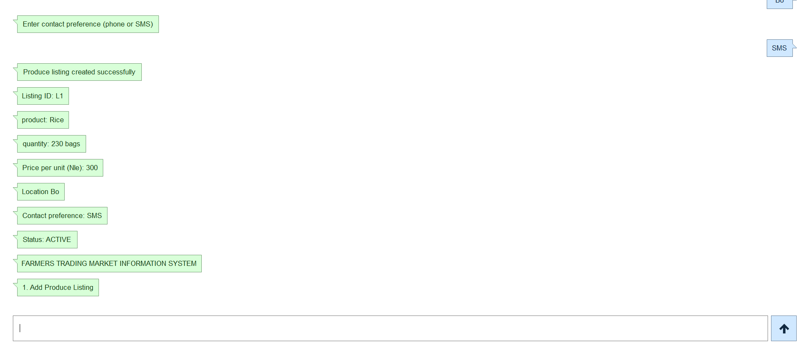
Listing creation: validated produce, assigned ID and ACTIVE status.

Figure B3 — ACTIVE search
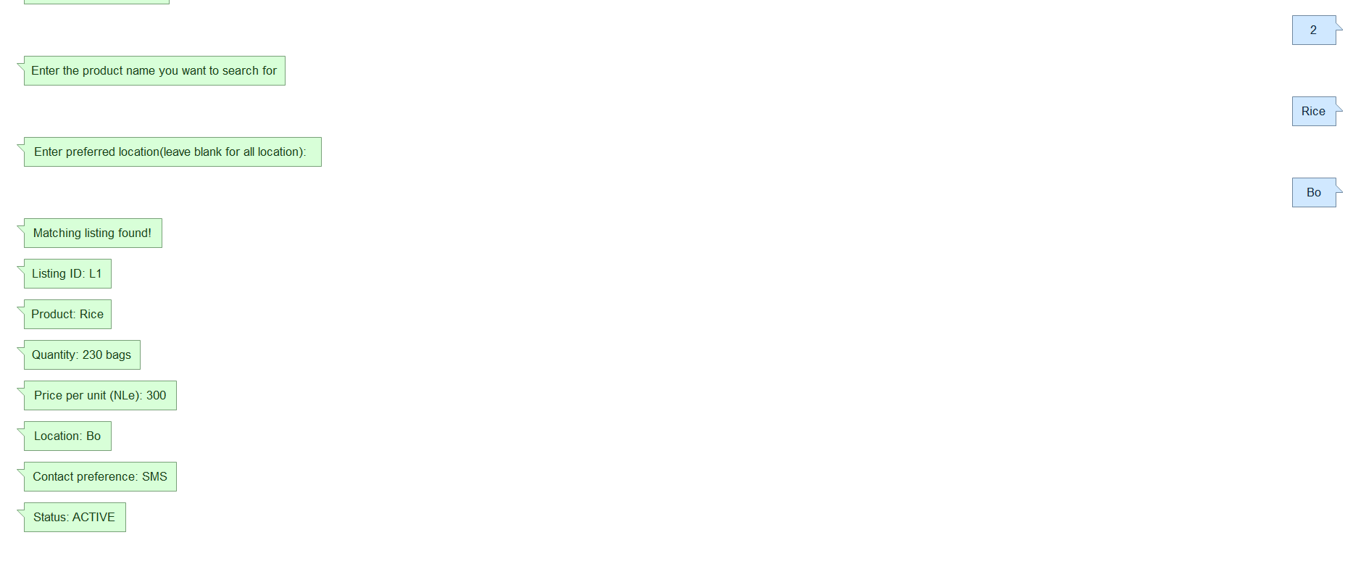
Search: matching product, quantity, price, location and contact preference.

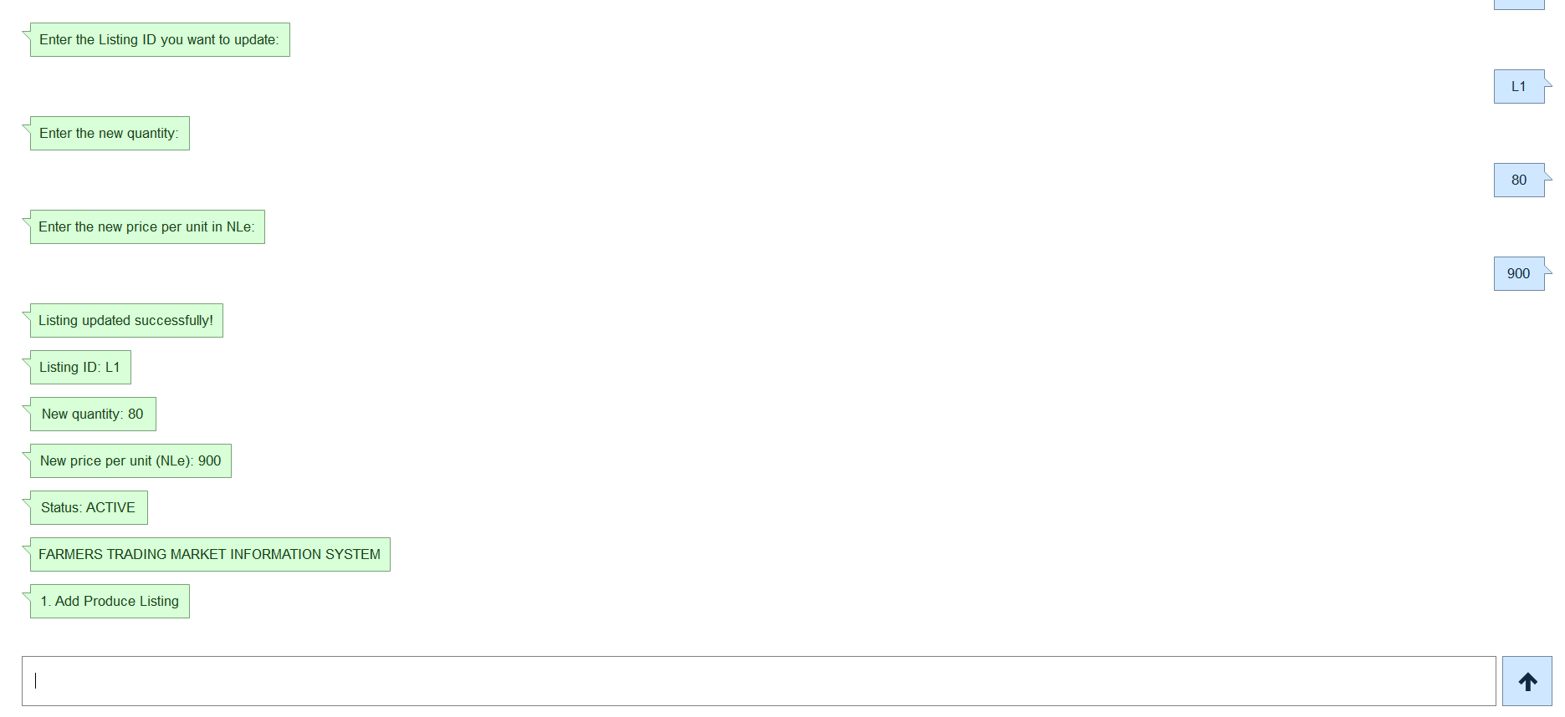
Figure B4 — UpdateListing

Update: successful changes to quantity and price.

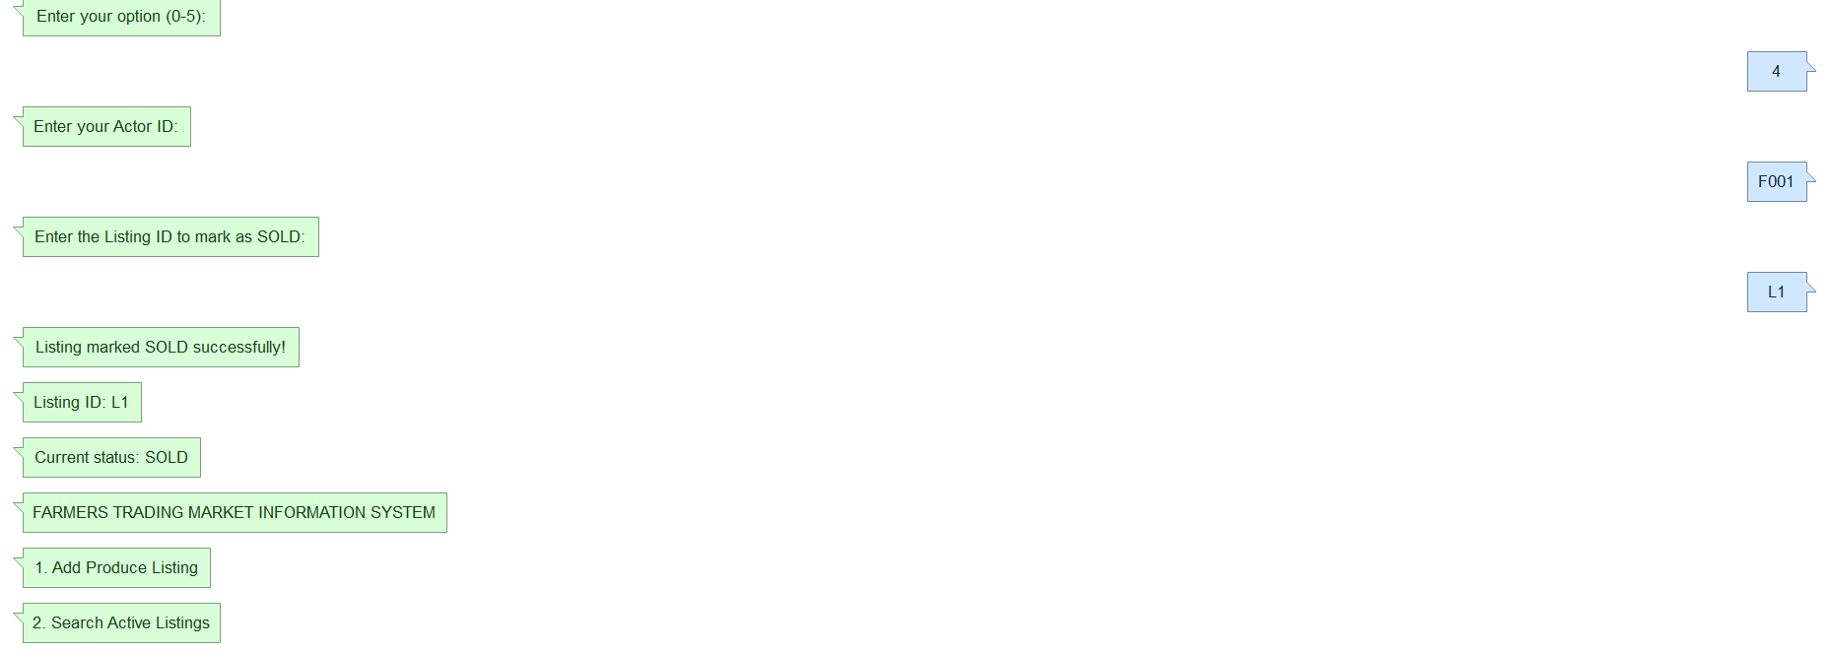
Figure B5 — Mark SOLD and search

SOLD result: status confirmation and absence from subsequent ACTIVE search.

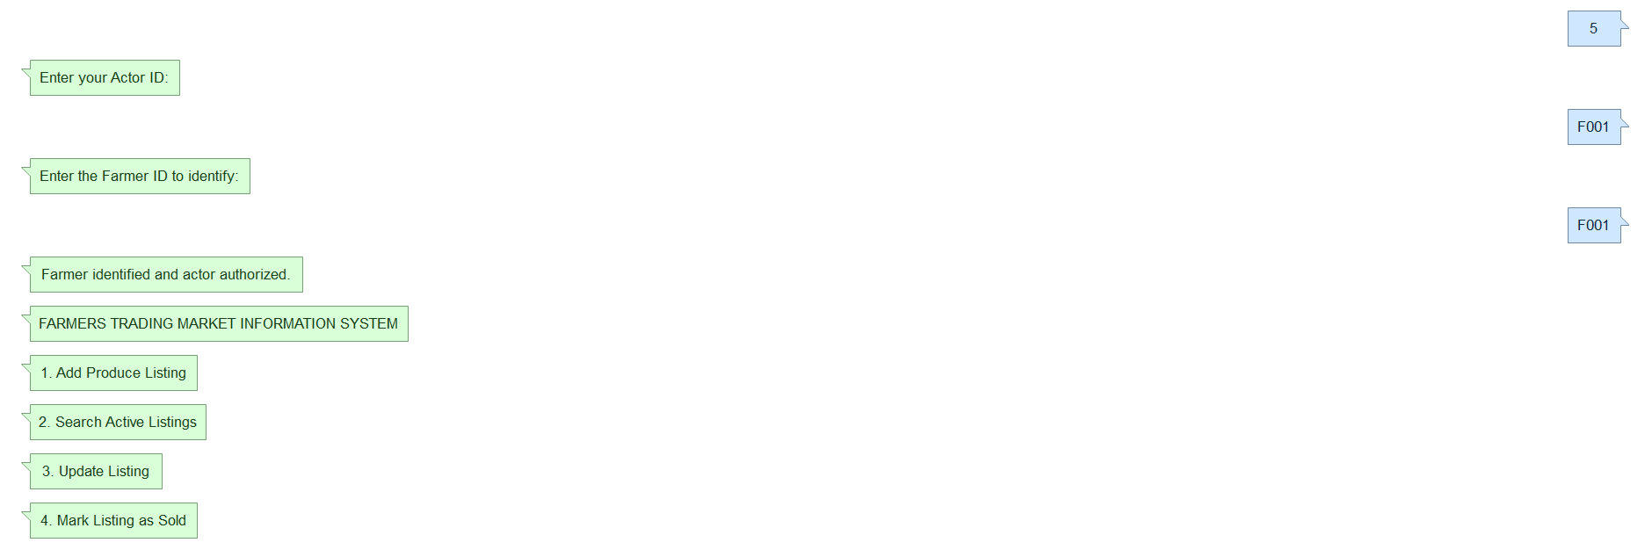
Figure B6 — IdentifyFarmer

